4.4: a) 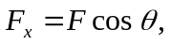 where is the angle that the rope makes with the ramp (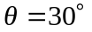 in this problem), so 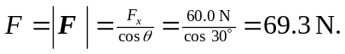
b) 